WRONG ADVICE…according to the scientists.

ALBERTA CANADA 31 May 2019
“Air quality conditions in Calgary and other parts of southern Alberta were much worse on Friday. Calgary’s AQHI level was a 10+ on Friday morning. That risk was forecast to remain very high into Friday night.”
“The Calgary Board of Education said principals make decisions based on local conditions, but the board’s guidelines are to consider indoor recess and lunch for students when the AQHI reaches 10+. When it comes to other outdoor activities, Calgary Minor Soccer advises games and practices should be delayed or rescheduled if the AQHI reaches 7 or higher.”
https://globalnews.ca/news/5339226/alberta-air-quality-forecast-may-31/
Look at the Canadian Index numbers below. So authorities wait for the index to get to the higher end of the scale before they protect their children from the toxic particulates and gasses?
Authorities are failing in their duty of care if we read the World Health Organisation’s Group 1 carcinogenic substances list…Mustard Gas, Asbestos, Formaldehyde AND Particulate Matter!

In fact there should not be a colour graduated HEALTH INDEX.
There should only be two colours. GREEN and RED.
All particulate matter is harmful; it is not a matter of ‘RISKing’ it.
If they want to assign colours, it should be GREEN when there is clean air and then after the air starts to become contaminated the colour turns Red and stays RED from then on.
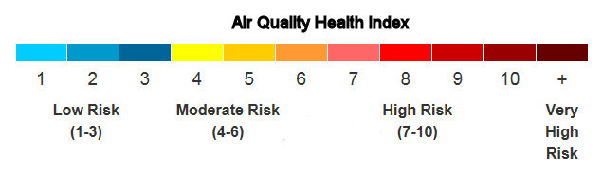

ALBERTA WILDFIRE ON RADIO 770CHQR
Dr. Ted Jablonski -
“Wildfire smoke produces particulate matter, some of which is often less than one micron in size. A human hair, by comparison, is about 60 microns in diameter.
That fine particulate matter can get embedded deep within lungs and cause irritation and inflammation.”
No, smoke is primarily made up of fine particulates (PM2.5s). It does not only cause irritation and inflammation it is toxic, it is a carcinogen, and can also cross over into the blood stream and cause cancer not only in the lungs but in other organs as well.
The AQHI was at 10 and I could not believe Dr Jablonski said healthy kids could go outside in the smoke, after he had said that the level equated to smoking a packet of cigarettes.
But then that doesn’t surprise me when he said he goes against all the scientific health advice and goes running in Class 1 carcinogenic conditions!
https://globalnews.ca/news/5339573/fire-smoke-health-mask-air-alberta/

